Car Door Alarm

Partners: Daniel Cerdeira & Nichelle Outlaw

The goal of this application is to learn how to use the digital input and output (I/O) pins of the MSP430G2553 microcontroller. As a real-world application, we examine a car door alarm system. In this section, we provide the equipment list, the layout of the circuit, and the procedure.

14.1.1 *Equipment List*

Following is a list of the equipment to be used in this application.

• Five LEDs

• Five 220-Ω resistors

• Five push buttons

• One 100-*η*F capacitor

14.1.2 *Layout*

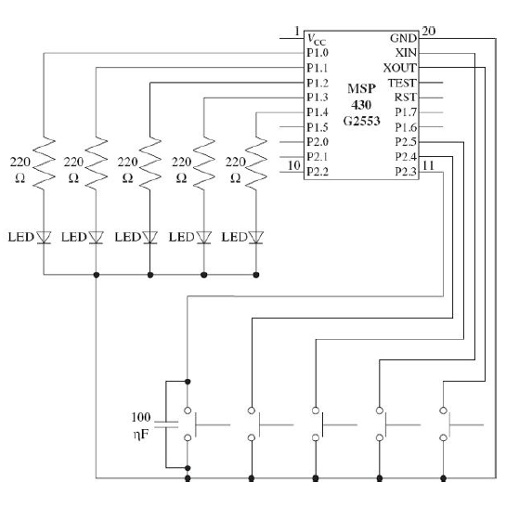

14.1.3 *System Design Specifications*

The design steps of the car door alarm system are as follows: In the first part of the application, we will assume that four push buttons are placed between the four car doors and the chassis. When a button is not pressed, it means that door is open and a warning should be given. This is done by an LED representing that door. When the same button is pressed, it means that door is closed now and the warning should be reset (or the LED should be turned off).

In the second part of the application, a lock button and lock warning LED will be added to the system. When the lock button is pressed, the car is locked and the lock warning LED is off. When the lock button is pressed again, it means that the car is unlocked now. Therefore, the lock warning LED should turn on. Initially, the car is not locked. Therefore, the lock warning LED must turn on. Also, the lock button cannot be used if all doors are not closed. As long as the car is locked, doors cannot be opened.

Normally, mechanical systems are used for this purpose. In this application, this property is simulated by using LEDs. After the car is locked, even releasing the buttons (placed between the doors and the chassis) cannot turn on the LEDs. This way, we will assume that the doors are still closed. The user should press all buttons (placed between the doors and the chassis), then press the lock button in order to unlock the system again.

References: Ünsalan, C., & Gürhan, H. D. (2014). Programmable microcontrollers with applications: MSP430 LaunchPad with CCS and Grace. New York: McGraw-Hill Education.